**A**

**MINI-PROJECT REPORT**

**On**

**AN OVERVIEW OF FOREIGN DIRECT INVESTMENT (FDI) IN INDIA**

Submitted to,

**SHIVAJI UNIVERSITY, KOLHAPUR**

In partial fulfilment of the requirement for the award of degree of

**BACHELOR OF BUSINESS ADMINISTRATION**

Submitted by,

**MR. OMKAR MAHADEV KADAM**

Under the guidance of

**DR. PRATIBHA A. JAGTAP**

(M.Com., MBA, M.Phil.., Ph.D., B.Ed., SET)



**Through**

**RAJARAMBAPU INSTITUTE OF TECHNOLOGY,**

**DEPT.OF MANAGEMENT STUDIES**

**RAJARAMNAGAR, TAL. -WALWA, DIST.-SANGLI**

**2023-24**

**A**

**CERTIFICATE**

This is to certify that, the project work entitled,

**AN OVERVIEW OF FOREIGN DIRECT INVESTMENT (FDI) IN INDIA**

Submitted By

**MR. OMKAR MAHADEV KADAM**

In partial fulfilment of the requirement for the award of degree of

**BACHELOR OF BUSINESS ADMINISTRATION**

Under the guidance of

**DR. PRATIBHA A. JAGTAP**

(M.Com., MBA, M.Phil.., Ph.D., B.Ed., SET)

Submitted To,

**SHIVAJI UNIVERSITY, KOLHAPUR**

The project report submitted through the Head of Department, Rajarambapu Institute of Technology, Rajaramnagar during the academic year 2023-24.

HOD. -BBA Director

RIT, Rajaramnagar RIT, Rajaramnagar

**CERTIFICATE**

This is to certify that the Mini-Project Work entitled,

**AN OVERVIEW OF FOREIGN DIRECT INVESTMENT (FDI) IN INDIA**

Submitted by

**MR. OMKAR MAHADEV KADAM**

Under the guidance of

**DR. PRATIBHA A. JAGTAP**

(M.Com., MBA, M.Phil.., Ph.D., B.Ed., SET)

Submitted to

**SHIVAJI UNIVERSITY, KOLHAPUR**

In partial fulfilment of the degree of

**BACHELOR OF BUSINESS ADMINISTRATION**

Under my guidance & supervision. To the best of knowledge of belief, the work presented has not been submitted earlier for the degree or diploma.

Date: 30.09.2023 **Dr. Pratibha A. Jagtap**

Place: Rajaramnagar [ Project Guide]

**DECLARATION**

To,

Director,

R. I. T, Rajaramnagar

I under signed Mr. Omkar Mahadev Kadam,hereby declare that the project report entitled as *An Overview of Foreign Direct Investment (FDI) In India, is* a genuine and bonafied work prepared by me under the guidance of Dr. Pratibha A. Jagtap. The empirical findings in the report are passed on data collected by myself the matter presented in this report is not copied from any source. I understand that any such copy is liable to be punished in way the University Authorities deemed to be feet.

Date: -30.09.2023

Place: -Rajaramnagar Mr. Omkar M. Kadam

**ACKNOWLEDGEMENT**

To list all helped me is difficult because they are so numerous and the depth is so enormous. I would like to acknowledge the following as being idealistic Channel and fresh dimension in the completion of this project.

I take this opportunity to thank the Shivaji University for giving me chance to the project. I would like to thank to Head of Department, for providing the necessary facilities required for completion of this project.

I would also like to express my sincere gratitude towards my project guide Dr. Pratibha A. Jagtap whose guidance and care made the project successful. I would like to thank my college library, for having provided various reference books and magazines related to my project.

Lastly, I would like thank each and every person who directly or indirectly helped me in the completion of the project, especially my parents and my peers who supported me throughout my project.

Place: Rajaramnagar Mr. Omkar M. Kadam

**INDEX**

|  |  |  |
| --- | --- | --- |
| **CHAPTER**  **NO.** | **PARTICULARS** | **Page No.** |
| **1.** | **1.** **INTRODUCTION TO STUDY**   * 1. Need or Importance of The Study   2. Review of Literature   3. Objective of The Study   4. Scope of The Study   5. Importance of The Study   6. Research Methodology   1.6.1) Data Sources  1.6.2) Sampling Design  1.6.3) Data Analysis | 9  10  11  14  14  14  15 |
| **2.** | 1. **THEORETICAL BACKGROUND**   2.1) Meaning and Definition  2.2) Nature  2.3) Scope  2.4) Types  2.5) Functions  2.6) Importance | 18  18  19  20  20  21 |

|  |  |  |
| --- | --- | --- |
| **CHAPTER**  **NO.** | **PARTICULARS** | **Page No.** |
| **3.** | 1. **INTRODUCTION OF FOREIGN DIRECT INVESTMENT**     1. Introduction    2. History    3. FDI Structure    4. Department    5. Product and Service    6. Awards    7. Human Resource Scenario in FDI    8. Operation Management in FDI    9. Marketing Scenario in FDI | 23  23  24  24  24  25  26  26  26 |
| **4.** | 1. **DATA ANALYSIS AND INTERPRETATION**     1. Financial year-wise FDI Inflow Data    2. Top Investing Countries FDI Equity Inflow into India (US$ million)    3. Sectors Attracting Highest FDI Equity Inflow    4. States Attracting Highest FDI Equity Inflow | 28  30  32  36 |
| **5.** | 1. **Finding and Suggestion**     1. Finding    2. Suggestion | 39  39 |
|  | **Conclusion** | 41 |

|  |  |  |
| --- | --- | --- |
|  | **Bibliogr****aphy** | 42 |

**CHAPTER NO. 1**

**INTRODUCTION TO STUDY**

**INTRODUCTION TO STUDY**

* **INTRODUCTION**

Foreign direct investment (FDI) plays a vital role in the economic development of countries, including India. It involves the investment of capital by foreign entities in domestic businesses or projects, with the aim of establishing a lasting interest and exerting significant influence on the operations and management of the invested entity.

India has been a favored destination for FDI due to its large consumer market, skilled labor force, and favorable investment policies. The Indian government has implemented several reforms to attract foreign investors and promote economic growth. These reforms include liberalizing investment rules, simplifying procedures, and offering various incentives and benefits to foreign investors.

FDI in India can be categorized into two forms: greenfield investments and mergers and acquisitions (M&A). Greenfield investments refer to the establishment of new businesses or projects by foreign investors, whereas M&A involve the acquisition of existing Indian companies by foreign entities.

The sectors that attract significant FDI inflows in India include information technology and business process management, telecommunications, automobiles, pharmaceuticals, retail, and real estate. These sectors offer attractive opportunities for foreign investors, given the growing middle-class population and increasing consumer demand in India.

FDI inflows have a positive impact on the Indian economy, contributing to job creation, technological advancements, and infrastructure development. It also helps in improving the balance of payments and promoting exports. Additionally, FDI acts as a catalyst for domestic investment, as it encourages local businesses to enhance their competitiveness and attract foreign partners.

However, there are challenges associated with FDI in India, such as bureaucratic hurdles, complex regulations, and a lack of robust infrastructure. These obstacles can deter foreign investors and hinder the growth of FDI inflows.

In recent years, India has witnessed a steady increase in FDI inflows, reflecting the confidence of foreign investors in the country's economic potential. The government continues to undertake reforms to further improve the ease of doing business and attract more FDI.

In conclusion, foreign direct investment in India plays a crucial role in driving economic growth and development. It offers numerous opportunities for foreign investors in various sectors and contributes to job creation, technological advancements, and infrastructure development. The Indian government's commitment to reform and improve the investment climate further enhances the attractiveness of India as a destination for FDI.

Foreign Direct Investment (FDI) plays a crucial role in India's economic development, contributing to various sectors such as manufacturing, services, and infrastructure. Here is an overview of FDI in India:

1. Policy Framework: India has implemented several policy measures to attract FDI, including liberalizing sectors, simplifying procedures, and offering incentives. The government has also launched initiatives like Make in India and Digital India to promote investment.

2. FDI Inflows: India has witnessed significant growth in FDI inflows over the years. In the financial year 2020-21, FDI inflows reached a record high of $81.72 billion, despite the global economic slowdown caused by the COVID-19 pandemic.

3. Sectors attracting FDI: FDI inflows are primarily directed towards sectors such as services, computer software and hardware, telecommunications, construction, trading, automobile, and chemicals. The manufacturing sector has also seen a rise in FDI inflows in recent years.

4. Major Investing Countries: The top investing countries in India include Singapore, Mauritius, the Netherlands, Japan, and the United States. These countries invest in various sectors, contributing to India's economic growth.

5. Employment Generation: FDI inflows have led to the creation of job opportunities in India. The manufacturing sector, in particular, has witnessed significant employment generation due to FDI investments.

6. Technology Transfer: FDI brings advanced technology and expertise to India, promoting innovation and improving productivity in various sectors. This technology transfer helps in upgrading the domestic industries and increasing competitiveness.

7. Challenges: Despite the positive impact of FDI, India faces challenges such as bureaucratic procedures, complex regulations, and infrastructure gaps. These challenges need to be addressed to further enhance the FDI inflows.

8. Future Outlook: India aims to attract more FDI in sectors like healthcare, education, renewable energy, and digital technologies. The government continues to introduce reforms and policies to make India an attractive investment destination.

In conclusion, FDI has played a significant role in India's economic growth and development. The government's efforts to improve the investment climate and attract more foreign investments are expected to further boost FDI inflows in the coming years.

* 1. **) Need Or Importance of The Study**

By considering the need or importance role of an overview of foreign direct investment in India, the researcher is kindly interested to study these concepts and know its application.

* **Need –**

Foreign Direct Investment (FDI) is crucial for India’s economic development and growth. Here are some key reasons highlighting the need for FDI in India.

1. Capital Inflows: FDI brings in much- needed capital to finance investment projects in India. It helps bridge the investment gap by supplementing domestic saving and boosting overall investment level. This capital inflow contributes to economic growth, infrastructure development, and industrial expansion.
2. Technology Transfer: FDI facilitates the transfer of advanced technologies, technical know-how, and managerial expertise to the Indian economy. This technology transfer enhances productivity, promotes innovation, and upgrade the skill set of the domestic workforce. It helps in improving the quality and competitiveness of Indian industries.
3. Employment Generation: FDI plays a significant role in creating employment opportunities. Foreign investors often establish new ventures or expand existing operation, leading to job creation across various sectors. This is particularly important for India, given its large population and the need to generate employment for its growing workforce.
4. Export Promotion: FDI can contribute to increasing export competitiveness. Foreign companies often establish a production facility in India to cater to both domestic and international markets. This boost exports, diversifies the export basket, and reduces dependence on traditional sectors. FDI also helps Indian companies integrate into global value chains, enhancing their exports capabilities.
5. Infrastructure Development: FDI inflows can contribute to the development of infrastructure in India. Foreign investors often invest in sectors such as telecommunication, energy, transportation, logistics, which are critical for improving connectivity and efficiency. This, is turn supports overall economic development and attracts further investment.
6. Improved balance of payments: FDI inflows contribute to the balance of payments by increasing foreign exchange reserves. It helps in reducing the current account deficit and provides stability to the currency. This is particularly important for a country like India, which relies on imports for various goods and services.

* **Importance –**

The study of foreign direct investment (FDI) in India is important for several reasons. Here are some of the key reasons and the role of the study.

1. Economic Growth: FDI plays a crucial role in driving economic growth in India. By attracting foreign investment, the country can benefit from capital inflows, technological advancement, job creation and increased productivity. Studying FDI helps understand the impact of investment on economic growth and identify strategies to attract more FDI.
2. Employment Opportunities: FDI has the potential to generate employment opportunities in various sectors. By studying FDI patterns and trends, policymakers can identify sectors with high potential for job creation and implement targeted policies to maximize employment benefits.
3. Market Access: FDI enables domestic companies to access global market thorough collaboration’s, joint ventures, and export-oriented production. Understanding the role of FDI in markets accesses helps in identifying sectors where India can leverage foreign investment to enhance its exports competitiveness.
4. Policy Formulation: Studying FDI in India provides insights of the effectiveness of existing policies and regulations governing foreign investment. It helps policymakers identify areas where policy reforms are needed to attract more FDI, remove barriers, and create a favorable investment climate.
5. Sectoral Analysis: FDI flows vary across sectors, and studying the sectors specific FDI trends helps in identifying sectors that are attracting substantial investment and those that need further attention. It aids policymakers in formulating sectors-specific strategies to maximize FDI benefits.

**1.2) Review of Literature**

1. Dr. Arvind Subramanian (2011) Dr. Subramanian's research examines the impact of foreign direct investment (FDI) on India's economic growth. The study finds a positive correlation between FDI inflows and GDP growth, suggesting that FDI has played a significant role in India's economic development.

2. Dr. Pravakar Sahoo (2014) Dr. Sahoo's research investigates the determinants of FDI inflows in India. The study finds that factors such as market size, infrastructure, political stability, and trade openness significantly influence FDI inflows. The research suggests that improving these factors can attract higher levels of FDI

3. Rupa Chanda (2008) Chanda’s research focuses on the impact of FDI on employment generation in India. The study finds that FDI inflows have positively contributed to job creation, particularly in sectors such as manufacturing and services. The research highlights the importance of FDI in addressing India's unemployment challenges.

4. Pinaki Chakraborty (2013) Chakraborty’s research examines the regional distribution of FDI inflows in India. The study finds that FDI tends to concentrate in states with better infrastructure, higher human capital, and more favorable business environments. The research suggests the need for regional policies to attract FDI to less-developed regions.

5. Dr. Sharmila Kantha (2017) Dr. Kantha's research analyzes the impact of FDI on the agricultural sector in India. The study finds that FDI inflows have led to technology transfer, increased productivity, and improved market access for Indian farmers. The research highlights the potential benefits of FDI in modernizing the agricultural sector.

6. Dr. Nagesh Kumar (2007) Dr. Kumar's research examines the role of FDI in promoting exports in India. The study finds that FDI inflows have a positive impact on export performance, suggesting that FDI plays a crucial role in enhancing India's competitiveness in the global market.

7. K.R. Gupta (2012) Gupta's research investigates the impact of FDI on the manufacturing sector in India. The study finds that FDI inflows have contributed to technological upgrading, increased productivity, and improved competitiveness in the manufacturing sector. The research emphasizes the importance of FDI in promoting industrial development.

8.Rajesh Chadha (2016) Chadha's research explores the spillover effects of FDI on domestic firms in India. The study finds that FDI inflows have positive spillover effects on domestic firms, including technology transfer, knowledge diffusion, and improved productivity. The research highlights the potential benefits of FDI for local industries.

9. Alokesh Barua (2015) Barua's research examines the impact of FDI on the financial sector in India. The study finds that FDI inflows have contributed to the development of the financial sector, including the expansion of banking services, increased access to credit, and improved financial stability. The research underscores the role of FDI in strengthening the financial system.

10. Biswajit Nag (2019) Nag’s research investigates the impact of FDI on the environment in India. The study finds that FDI inflows have both positive and negative environmental effects. While FDI can bring in cleaner technologies and environmental standards, it can also lead to increased pollution and resource depletion. The research emphasizes the need for sustainable FDI policies.

11. Sushanta Mallick (2010) Mallick’s research examines the impact of FDI on income inequality in India. The study finds that FDI inflows have a mixed effect on income distribution, with some sectors experiencing increased inequality while others show a decrease. The research highlights the need for inclusive FDI policies to address inequality concerns.

12. Dr. Rajib Bhattacharyya (2018) Dr. Bhattacharyya's research investigates the role of FDI in promoting innovation in India. The study finds that FDI inflows have positively contributed to innovation activities, including research and development, technology adoption, and knowledge spillovers. The research emphasizes the importance of FDI in fostering innovation-driven growth.

13. Dr. Ashima Goyal (2013) Dr. Goyal's research examines the impact of FDI on the exchange rate in India. The study finds that FDI inflows have a significant effect on the exchange rate, leading to appreciation pressures. The research highlights the need for appropriate policy measures to manage the exchange rate impact of FDI.

14. Dr. Chiranjib Neogi (2016) Dr. Neogi's research investigates the impact of FDI on the services sector in India. The study finds that FDI inflows have contributed to the growth and diversification of the services sector, including sectors such as IT, telecommunications, and tourism. The research underscores the role of FDI in driving service-led economic development.

15.Dr. Deepika Wadhwa (2014) Dr. Wadhwa's research examines the role of FDI in the healthcare sector in India. The study finds that FDI inflows have facilitated the expansion of healthcare infrastructure, improved access to quality healthcare services, and enhanced medical technology capabilities. The research highlights the potential benefits of FDI in promoting healthcare development.

16. Manoj Pant (2011) Pant's research investigates the impact of FDI on the education sector in India. The study finds that FDI inflows have contributed to the expansion and improvement of educational institutions, increased access to quality education, and enhanced skill development. The research emphasizes the role of FDI in promoting human capital development.

17. Nandita Dasgupta (2017) Dasgupta's research examines the impact of FDI on the real estate sector in India. The study finds that FDI inflows have led to increased investment in the real estate sector, enhanced urban infrastructure, and improved housing affordability. The research highlights the role of FDI in supporting the growth of the real estate market.

18. Dr. Saikat Sinha Roy (2013) Dr. Sinha Roy's research investigates the impact of FDI on the retail sector in India. The study finds that FDI inflows have contributed to the modernization of the retail industry, improved supply chain efficiency, and increased consumer choice. The research underscores the potential benefits of FDI in the retail sector.

19. Dr. Ananya Ghosh Dastidar (2015) Dr. Dastidar's research examines the impact of FDI on the agricultural supply chain in India. The study finds that FDI inflows have facilitated the development of agribusiness, improved farm-to-market linkages, and increased farmers' income. The research highlights the potential benefits of FDI in transforming the agricultural sector.

20. Dr. Rana Hasan (2012) Dr. Hasan's research investigates the impact of FDI on the informal sector in India. The study finds that FDI inflows have had limited direct effects on the informal sector, but they can indirectly benefit informal workers through increased demand and productivity in the formal sector. The research emphasizes the need for inclusive growth strategies to address the challenges faced by the informal sector in the context of FDI.

**1.3) Objective of The Study**

1. To know about foreign direct investment (FDI) In India.
2. To identify the various determinants of foreign direct investment (FDI).
3. To examine sector wise, year wise analysis of foreign direct investment (FDI) In India.
4. To evaluate country wise flow of foreign direct investment (FDI) In India.

**1.4) Scope of The Study**

1. Conceptual Scope: -

The conceptual scope of the study is limited to “An overview of Foreign Direct Investment (FDI) In India”

1. Geographical scope: -

The present study covers entire state and country.

1. Chronological Scope: -

The period for the present study is for one month.

1. Analytical Scope: -

For present study different statistical tool such as tabulation, graphical presentation, average etc. has been used.

**1.5) Importance of The Study**

1. Researcher has got practical knowledge or information about “An overview of foreign direct investment (FDI) In India’.
2. Researcher has understood organizational policy, work culture of the organization.
3. Researcher has understood different communication tool used in the organization.
4. Researcher has understood the organizational structure.

**1.6) Research Methodology**

**1.6.1) Data sources**

* Secondary Data -

Secondary data refers to data that has been previously collected by someone else or for a different purpose. It is data that is not generated firsthand by the researcher but is obtained from existing sources such as government reports, academic studies, or surveys. Researchers analyze and interpret secondary data to gain insights and draw conclusions for their own research objectives.

Sources of secondary data are websites, internet, books, magazines, articles, newspapers, Government publication etc.

For present research researcher have used Internet, Websites, books, articles, government publication etc.

**1.6.2) Sampling Design**

1. Sample Size –

Sample of 5 years data was taken into study, and their data was collected.

1. Sample Techniques –

Types of sampling –

* Probability Sampling: - Probability sampling is a sampling method that involves randomly selecting a sample, or a part of the population that you want to research. It is also sometimes called random sampling.

Types of Probability Sampling –

* Simple Random sampling: - Simple random sampling is a method of selecting a sample from a population in which each individual has an equal chance of being chosen, ensuring a representative and unbiased sample for statistical analysis.

To study the project, a simple random sampling technique is used.

**1.6.3) Data Analysis**

Data analysis tool are defined as a series of charts, maps and diagram designed to collect, interpretate and present data for a wide range of application and industries.

For present study researcher has used statistical tool such as charts, Graphs and Diagrams

**CHAPTER NO. 2**

**THEORETICAL BACKGROUND**

**2.1) Meaning and Definition**

* **Meaning:**

The last decade of the 20th century witnessed a drastic increase in foreign direct investment (FDI), accompanied by a marked change in the attitude of most developing countries towards inward investment. FDI flows have grown in importance relative to other forms of international capital flows, and the resulting production has increased as a share of world output. Naturally, the attitude towards foreign capital was one of fears and sufficient, an account of the previous bitter experience draining away of the resources from the country, once better known as the golden birds.

Foreign direct investment (FDI) in India has played an important role in the development of the Indian economy during the recession. FDI in India has – in a lot of ways – enabled India to achieve a certain degree of financial stability, growth and development. This money has allowed India to focus on the areas that may have needed economic attention and address various problems that continue to challenge the country. The factors that attracted investment in India are stable economic policies, availability of cheap and quality human resources, and opportunities of new unexplored markets. Mostly FDI are flowing in service sector and manufacturing sector recorded very low investments. The investments in service sector will enhance the benefit of flow of funds to the home country. Presently India is contributing about 17% of world total population but the share of GDP to world GDP is 2%. India has been ranked at the second place in global foreign direct investments in 2010 and will continue to remain among the top five attractive destinations for international investors during 2020-22 period, according to United Nations Conference on Trade and Development (UNCTAD) in a report on world investment prospects titled, 'World Investment Prospects Survey 2019-22.

* **Definition:**

Foreign Direct Investment (FDI) refers to the investment made by companies or individuals from one country into businesses or projects located in another country. It involves acquiring a significant ownership stake in a foreign enterprise, typically with the purpose of establishing a lasting interest and exerting control over the operations. FDI can take various forms, including equity investments, reinvested earnings, and intercompany loans, and it plays a crucial role in promoting economic growth, job creation, technology transfer, and overall development in both the host and home countries.

**2.2) Nature:**

The nature of the study on FDI in India would involve a comprehensive analysis of various aspects related to foreign direct investment in the country. This study would aim to understand and examine the trends, patterns, determinants, impacts, and policy frameworks surrounding FDI in India.

The study may include the following elements:

1. FDI Inflows: Examining the trends and patterns of FDI inflows into India over a specific period, including the sectors and countries contributing the most.

2. Sectoral Analysis: Assessing the distribution of FDI across different sectors in India, identifying the sectors that have attracted significant FDI and the reasons behind their attractiveness.

3. Economic Impact: Evaluating the economic impact of FDI in India, such as its contribution to GDP growth, employment generation, technology transfer, export promotion, and overall industrial development.

4. Comparative Analysis: Comparing India's FDI performance with other countries or regions to identify areas where India can learn from best practices and improve its FDI attractiveness.

5. Challenges and Opportunities: Identifying the challenges and opportunities associated with FDI in India, including issues related to infrastructure, bureaucracy, legal framework, ease of doing business, and investment protection.

The nature of the study would involve a combination of quantitative analysis, qualitative research, and policy analysis to provide a comprehensive understanding of FDI in India and its implications for the country's economic development.

**2.3) Scope:**

FDI is the investment of funds that is handled by an organization from one country to another. The intent behind it is to establish “lasting interest”. According to OECD (Organization for Economic Co-Operation and Development). Lasting interest is determined when the organization acquires a minimum of 10% voting power in the other organization. Here are some of the benefits that come with FDI investments:

1. Increased Economic growth and higher rate of employment – The creation of jobs is amongst the most obvious advantage that comes with FDI. It is amongst the most important reason that helps with the growth of nation. Increased FDI boosts the overall service as well as manufacturing sector. This brings in jobs for both skilled as well as unskilled labor.

2. Human Resource Development – The less obvious advantage that comes with FDI is the competence of workforce and the human capital knowledge. Skills that are gained are then enhanced with the help of experience and training.

3. Backward Areas are being developed – Most crucial benefit that comes with FDI for developing country. This provides an instant boost to the social economic status in the area.

4. Finance and Technology provisions – Businesses tend to get an access of the latest financing tools, operational practices, as well as technologies from across the world. This results in an enhanced efficiency and effectiveness of the industry.

5. Increased Exports – FDI helps enhance domestic consumption. These products are mostly available in the global markets. 100% Export Oriented Units and Economic Zones have further boosted exports.

FDI India is one of the top FDI experts in India. They help the organizations to accomplish unfamiliar interests in a hassle-free way and facilitate their approach to get unfamiliar speculations that they have been searching for. The team of experts in FDI India leaves no stone improved in making the FDI cycle for its customers simple as they give minimal effort high caliber and cycle driven Foreign Direct Investments.

**2.4) Types:**

There are mainly two types of FDI - Horizontal and Vertical. However, two other types of FDI have emerged – Conglomerate and Platform FDI.

1. Horizontal FDI: This type of FDI involves the investment in the same industry or business activity abroad as the one conducted domestically. It aims to expand the market reach and gain a competitive advantage in the target country.

2. Vertical FDI: Vertical FDI occurs when a company invests in different stages of the production process or value chain in a foreign country. It can be either backward vertical FDI (investment in suppliers) or forward vertical FDI (investment in distribution channels or customers).

3. Conglomerate FDI: Conglomerate FDI refers to investments made by a company in a different industry or business that is unrelated to its existing operations. It is often driven by diversification strategies or the pursuit of new growth opportunities.

4. Platform FDI: Platform FDI involves establishing a subsidiary or base in a foreign country to serve as a hub or platform for conducting business operations in the region or globally. It is commonly used by multinational companies to centralize and coordinate their activities.

**2.5) Function:**

Foreign Direct Investment (FDI) plays several important functions in India, contributing to its economic growth and development. Here are some key functions of FDI in India:

1. Capital Inflow: FDI brings in much-needed capital into the Indian economy, which helps finance investment projects, infrastructure development, and expansion of existing businesses. It provides a stable and long-term source of investment that complements domestic savings and investment.

2. Technology Transfer: FDI facilitates the transfer of advanced technologies, know-how, and management practices from foreign companies to domestic firms. This helps improve productivity, innovation, and competitiveness in Indian industries, leading to technological upgradation and skill development.

3. Employment Generation: FDI contributes to job creation in India by setting up new businesses, expanding existing operations, and investing in sectors with high labor-intensive activities. It helps reduce unemployment and underemployment, particularly in sectors such as manufacturing, services, and construction.

4. Export Promotion: FDI plays a crucial role in boosting India's export potential. Foreign companies often establish production facilities in India to take advantage of the country's skilled workforce, cost competitiveness, and strategic location. This leads to increased export-oriented production and diversification of the export basket.

5. Economic Integration: FDI encourages economic integration by promoting trade and investment linkages between India and other countries. It strengthens economic ties, facilitates cross-border collaborations, and fosters knowledge sharing and learning from international partners.

6. Government Revenue Generation: FDI contributes to government revenue through taxes, duties, and royalties paid by foreign investors. It supports public finances, funds social welfare programs, and helps finance public infrastructure and development projects.

Overall, FDI plays a crucial role in India's economic development by attracting capital, technology, and expertise, creating employment opportunities, promoting exports, and enhancing productivity and competitiveness in various sectors of the economy.

**2.6) Importance:**

Foreign Direct Investment (FDI) holds significant importance for India's economic development and growth. Here are some key reasons why FDI is important for India:

1. Capital Inflow and Investment: FDI brings in much-needed capital into the Indian economy, supplementing domestic savings and investment. It helps bridge the investment gap and supports the financing of various sectors, such as infrastructure, manufacturing, technology, and services.

2. Economic Growth: FDI acts as a catalyst for economic growth by stimulating domestic investment, creating employment opportunities, and fostering technological advancements. It contributes to higher GDP growth rates, increased productivity, and improved living standards.

3. Infrastructure Development: FDI inflows contribute to the development of infrastructure in India. Foreign investors often invest in sectors such as telecommunications, power, transportation, and logistics, which helps improve the quality and capacity of infrastructure, supporting overall economic growth and development.

4. Boost to Domestic Industries: FDI encourages competition and stimulates domestic industries to become more efficient, productive, and globally competitive. It introduces best practices, managerial expertise, and operational efficiency, fostering a culture of continuous improvement and innovation among domestic firms.

5. Access to Global Markets: FDI provides Indian companies with opportunities to access global markets, supply chains, and distribution networks through partnerships or acquisitions with foreign investors. This helps Indian firms expand their reach, gain exposure to international markets, and enhance their competitiveness on a global scale.

6. Government Revenue and Fiscal Benefits: FDI contributes to government revenue through taxes, duties, and royalties paid by foreign investors. It strengthens public finances, supports social welfare programs, and helps finance public infrastructure and development projects.

Overall, FDI plays a vital role in India's economic development by attracting capital, technology, expertise, and market access. It contributes to economic growth, employment generation, technology transfer, infrastructure development, and export promotion, making it a key driver of India's progress towards becoming a globally competitive economy.

**CHAPTER NO. 3**

**INTRODUCTION OF FOREIGN DIRECT INVESTMENT**

**3.1) Introduction:**

Investment, which is also called creation of capital, is a vital determinant of a country’s economic growth. It is required to a great extent for the economy to grow. An appropriate level of capital together with labour, natural resources and advanced technology can bring about optimum growth levels in the economy by way of creation of capital goods which may be in physical, financial or human form. The other name of this capital is investment which comprises not only domestic but also foreign investments. Foreign investment inflows can reduce the domestic savings gap. On a general basis, these inflows foster growth in a developing economy. Multinational Corporation (MNC) is a proper tool to bring all the economies together on the global platform. There is a direct proportion between the expansion of these inflows and that of the MNCs. Backward and underdeveloped countries interested in speedy economic development are required to import world-class machinery, technical know-how, entrepreneurial skills, and foreign investments. Most of the world economies seeking growth, both short-term and long-term, has to some extent depend on foreign capital inflows. It cannot be denied that this capital infusion from foreign countries contribute to the ongoing phenomenon of economic growth, industrialization and modernization in numerous ways.

As a matter of fact, foreign direct investment is a significant component of total foreign investments. In such investments, the investor (an individual, a firm, a company, etc) from a different (foreign) nation invests in a business situated in host nation. Usually, the foreign investor acquires assets of the business or establishes business operations to get a controlling interest in the business established in host nation and is directly involved in its management when he invests either directly or via other affiliates.

**3.2) History:**

Foreign direct Investment is an investment made by an entity living outside the country where the investment is being made by either buying a company there or expanding its business in the domestic country.

Foreign direct investment (FDI) in India was introduced in under 1991 under the foreign exchange Management Act (FEMA) implementation by the then finance minister, Dr. Manmohan Singh. Its commerce with the baseline of 1 billion dollars in 1990.

**3.3) FDI Structure:**

**Manufacturer**

**Home**

**Forward**

**Vertical FDI**

**Horizontal**

**FDI**

**Backward**

**Vertical FDI**

**Country**

**Host**

**Country**

**Distributor**

**Manufacturer**

**Raw material**

**Supplier**

**3.4) Department:**

1. Prohibited Sector
2. Permitted Sector
3. Plantation Sector
4. Mining
5. Manufacture
6. Trading
7. Banking – Private Sector
8. Insurance
9. Pension Sector
10. Foreign Currency

**3.5) Product and Services:**

* **Product**

1. Insurance
2. Medical Devices
3. Pension
4. Power Exchange
5. Multi- Brand Retail
6. Food Products

* **Services:**

1. Broadcasting Carriage Services
2. Broadcasting Content Services
3. Air transport services
4. Hosing
5. Industrial parks
6. Telecom Services
7. E – Commerce Activity
8. Financial service

**3.6) Awards:**

1. Invest India:

- "Investment Promotion Agency of the Year" by the World Association of Investment Promotion Agencies (WAIPA) in 2017 and 2018.

2. Confederation of Indian Industry (CII):

- "Most Innovative Investment Promotion Agency" by the World Association of Investment Promotion Agencies (WAIPA) in 2016.

3. Department for Promotion of Industry and Internal Trade (DPIIT):

- "Top Investment Promotion Agency" by the World Association of Investment Promotion Agencies (WAIPA) in 2019.

4. Maharashtra Industrial Development Corporation (MIDC):

- "Best Investment Promotion Agency" by the World Association of Investment Promotion Agencies (WAIPA) in 2016.

5. Andhra Pradesh Economic Development Board (APEDB):

- "Best Investment Promotion Agency" by the World Association of Investment Promotion Agencies (WAIPA) in 2019.

**3.7) Human Resource Scenario of FDI:**

The human resource scenario in Foreign Direct Investment (FDI) in India is characterized by various factors that contribute to the development and growth of the local workforce. FDI inflows lead to the creation of employment opportunities, particularly in sectors such as manufacturing, services, and information technology. This results in job generation, reducing unemployment rates and improving the overall economic condition of the country.

Moreover, FDI brings with it advanced technologies, managerial expertise, and best practices, which necessitates skill development and training programs for the local workforce. This helps in enhancing their employability and competitiveness in the global market. Additionally, the presence of foreign companies through FDI exposes Indian workers to international work cultures and practices, fostering knowledge sharing and learning opportunities. This exposure, along with the transfer of technology and knowledge, contributes to the upskilling and capacity building of the local workforce, promoting innovation and adoption of modern practices. Overall, FDI in India has a positive impact on the human resource scenario, creating employment, promoting skill development, and enhancing the competitiveness of the local workforce.

**3.8) Operation Management in FDI:**

Operation management in Foreign Direct Investment (FDI) in India is crucial for the successful implementation and growth of FDI projects. It involves various aspects such as site selection, supply chain management, quality control, production planning and control, cost management, risk management, technology adoption, and continuous improvement.

Operation management starts with the selection of suitable locations for FDI projects, considering factors like infrastructure, skilled labour availability, and government policies. Efficient supply chain management ensures the smooth flow of goods and services by coordinating logistics, procurement, and distribution activities. Quality control measures are implemented to maintain standards and compliance with regulations. Production planning and control optimize resources and meet production targets, while cost management strategies aim to reduce costs and improve profitability. Risk management identifies and mitigates potential risks, ensuring business continuity. Technology adoption and continuous improvement foster innovation and enhance efficiency. Overall, operation management in FDI in India plays a vital role in ensuring effective and competitive business operations.

**3.9) Marketing Scenario in FDI:**

* The total FDI inflow into India from January to March 2022 stood at US$ 22.03 billon.
* While the FDI equity inflow for the same period was US$ 15.59 billion.
* India`s FDI inflow have increased 20 times from 2001-01 to 2021-22.
* According to the Department for promotion of industry and inflow stood at US$ 871.01

billion between April 2000 June 2022; This was mainly due to the government efforts

to improve the ease of doing business and relax FDI norms.

**CHAPTER NO. 4**

**DATA ANALYSIS AND INTERPRETATION**

* 1. **Financial Year -Wise FDI Inflow Data**

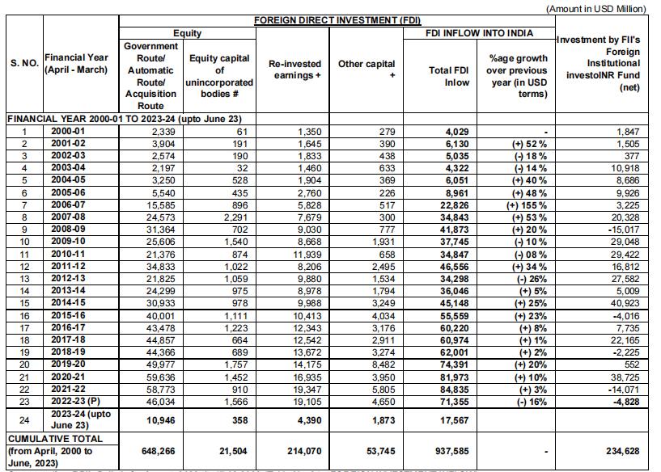

# **Cumulative FDI Inflow in India (April 2000 - March 2023) (US$ Million)**

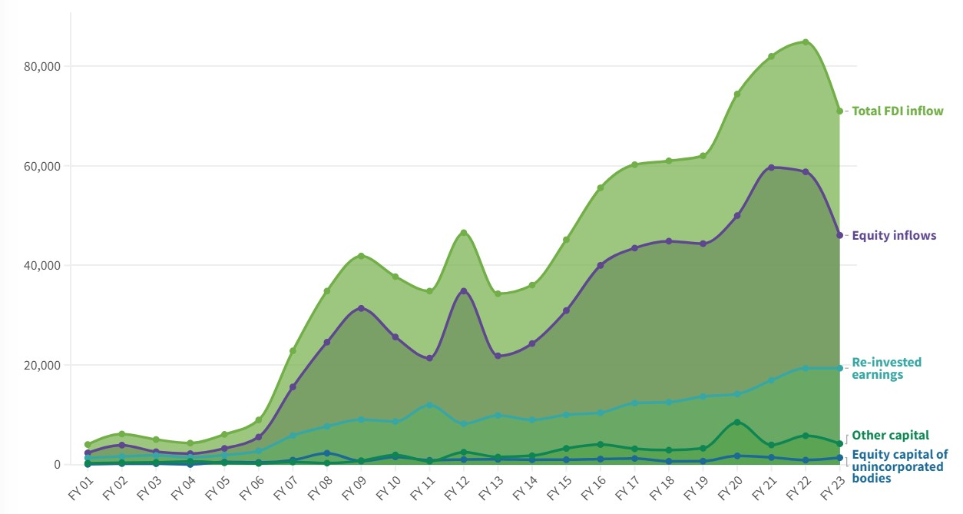

**Interpretation**

India’s advantageous demography and steady growth trajectory make it an appealing destination for foreign investment. In the last two decades (April 2000 – March 2023), India has attracted over US$919.63 billion in total FDI.

* 1. **Top Investing Countries’ FDI Equity Inflow into India (US$ Million)**

|  |  |  |  |  |  |
| --- | --- | --- | --- | --- | --- |
| **Country** | **FY 2021** | **FY 2022** | **FY 2023** | **Cumulative equity inflow (April, 2000-March, 2023)** | **Percentage share** |
| Mauritius | 5,639 | 9,392 | 6,134 | 1,63,876 | 26% |
| Singapore | 17,419 | 15,878 | 17,203 | 1,48,169 | 23% |
| USA | 13,823 | 10,549 | 6,044 | 60,196 | 9% |
| Netherland | 2,789 | 4,620 | 2,498 | 43,759 | 7% |
| Japan | 1,950 | 1,494 | 1,798 | 38,740 | 6% |
| UK | 2,116 | 1,657 | 1,738 | 33,875 | 5% |
| UAE | 4,203 | 1,032 | 3,353 | 15,578 | 2% |
| Cayman Island | 2,799 | 3,818 | 772 | 14,924 | 2% |
| Germany | 667 | 728 | 547 | 14,138 | 2% |
| Cyprus | 386 | 233 | 1,277 | 12,644 | 2% |

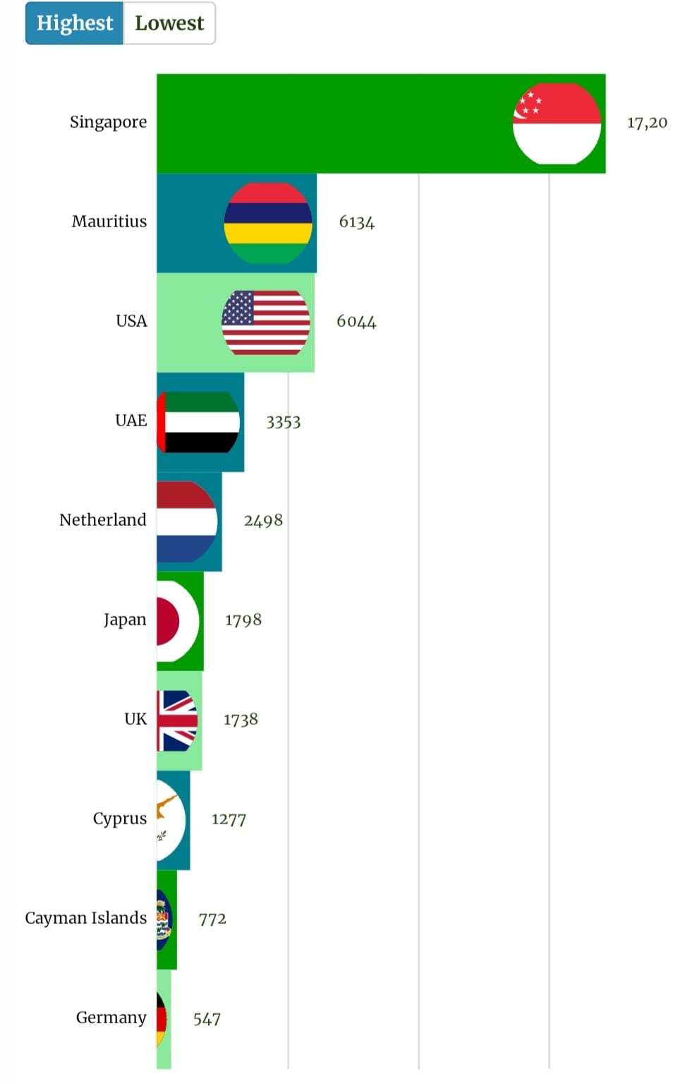

**Interpretation: -**

In FY 2023, Singapore accounted for maximum inward FDI in India at US$17.20 billion, followed by Mauritius (US$6.13 billion), the US (US$6.04 billion), UAE (US$3.35 billion), and the Netherlands (US$2.49 billion).

From April 2000 to March 2023, Mauritius was the top source of FDI equity inflow into India, accounting for 26 percent of investments worth US$163.87 billion. Singapore emerged as the second largest investor, contributing 23 percent of the investments in India during this period – valued at US$148.16 billion.

* 1. **Sectors Attracting Highest FDI Equity Inflow:**

|  |  |  |  |  |  |  |  |  |
| --- | --- | --- | --- | --- | --- | --- | --- | --- |
|  | **Sector** | **2017-18 - Apr-Mar** | **2018-19 - Apr-Mar** | **2019-20 - Apr-Mar** | **2020-21 - Apr-Mar** | **2021-22 - Apr-Mar** | **2022-23 - Apr-Sep** | **Total** |
| 1 | Metallurgical Industries | 371.76 | 598.84 | 2100.65 | 1340.47 | 2272.35 | 79.4 | 6763.48 |
| 2 | Mining | 36.41 | 223.58 | 199.23 | 168.77 | 344.61 | 161.26 | 1133.86 |
| 3 | Power | 1621 | 1105.64 | 672.16 | 373.63 | 525.66 | 540.25 | 4838.35 |
| 4 | Non-conventional Energy | 1204.46 | 1446.16 | 1393.39 | 797.21 | 1600.93 | 1410.97 | 7853.11 |
| 5 | Petroleum & Natural Gas | 24.18 | 138.43 | 805.76 | 102.81 | 56.41 | 19.35 | 1146.95 |
| 6 | Boilers and Steam Generating Plants | 68.13 | 0.01 | 0.08 | 0.9 | 0 | 0 | 69.12 |
| 7 | Prime Mover (Other Than Electrical Generators) | 159.06 | 244.92 | 85.35 | 279.97 | 25.08 | 71.16 | 865.54 |
| 8 | Electrical Equipment | 488.72 | 976.5 | 571.39 | 1411.95 | 683.7 | 747.32 | 4879.58 |
| 9 | Computer Software & Hardware | 6153.2 | 6415.21 | 7673.32 | 26144.69 | 14461.35 | 6281.9 | 67129.67 |
| 10 | Electronics | 196.87 | 451.88 | 422.36 | 375.31 | 417 | 130.61 | 1994.03 |
| 11 | Telecommunications | 6211.84 | 2667.91 | 4445.16 | 392.11 | 668.14 | 694.06 | 15079.22 |
| 12 | Information & Broadcasting (Including Print Media) | 638.67 | 1252.36 | 823.4 | 313.89 | 152.27 | 178.85 | 3359.45 |
| 13 | Automobile Industry | 2089.53 | 2623.22 | 2824.03 | 1637.44 | 6993.55 | 932.48 | 17100.25 |
| 14 | Air Transport (Including Air Freight) | 628.53 | 190.64 | 918.3 | 204.1 | 584.83 | 69.66 | 2596.05 |
| 15 | Sea Transport | 1051.49 | 279.25 | 198.58 | 294.2 | 393.81 | 131.86 | 2349.19 |
| 16 | Railway Related Components | 98.54 | 72.19 | 138.32 | 119.64 | 1.26 | 1.16 | 431.11 |
| 17 | Industrial Machinery | 462.82 | 338.18 | 424.63 | 253.33 | 320.66 | 154.19 | 1953.81 |
| 18 | Machine Tools | 45.16 | 44.93 | 28.83 | 20.91 | 31.23 | 27.45 | 198.51 |
| 19 | Agricultural Machinery | 17.2 | 5.78 | 102.31 | 142.59 | 268.73 | 732.7 | 1269.32 |
| 20 | Earth-moving Machinery | 29.18 | 34.16 | 14.08 | 39.39 | 60.6 | 21.69 | 199.1 |
| 21 | Miscellaneous Mechanical & Engineering Industries | 106.42 | 162.67 | 54.36 | 64.1 | 411.17 | 68.83 | 867.55 |
| 22 | Commercial, Office & Household Equipment | 20.97 | 11.78 | 2.65 | 47.25 | 17.24 | 12.77 | 112.67 |
| 23 | Medical and Surgical Appliances | 87.23 | 156.72 | 308.71 | 68.91 | 208.05 | 337.04 | 1166.65 |
| 24 | Industrial Instruments | 2.28 | 1.62 | 8.32 | 0.7 | 0.11 | 0 | 13.03 |
| 25 | Scientific Instruments | 5.53 | 3.15 | 23.23 | 9.42 | 7.57 | 67.49 | 116.39 |
| 26 | Fertilizers | 26.68 | 86.73 | 9.12 | 17.89 | 6.07 | 0.79 | 147.28 |
| 27 | Chemicals (Other than Fertilizers) | 1307.9 | 1980.99 | 1057.51 | 847.07 | 965.78 | 1307.15 | 7466.39 |
| 28 | Dye-stuffs | 0 | 1.52 | 5.14 | 4.44 | 2.94 | 0 | 14.05 |
| 29 | Drugs & Pharmaceuticals | 1009.96 | 265.97 | 517.79 | 1490.49 | 1414.24 | 698.94 | 5397.4 |
| 30 | Textiles (Including Dyed, Printed) | 454.45 | 198.14 | 323.52 | 298.67 | 247.75 | 53.13 | 1575.67 |
| 31 | Paper and Pulp (Including Paper Products) | 71.17 | 38 | 49.96 | 22.42 | 158.48 | 18.06 | 358.09 |
| 32 | Sugar | 7.9 | 1.1 | 0.46 | 24.94 | 0.55 | 0.12 | 35.06 |
| 33 | Fermentation Industries | 38.48 | 149.49 | 313.67 | 84.77 | 869.52 | 205.74 | 1661.67 |
| 34 | Food Processing Industries | 904.9 | 628.24 | 904.7 | 393.41 | 709.71 | 430.69 | 3971.66 |
| 35 | Vegetable Oils and Vanaspati | 85.12 | 116.22 | 79.97 | 44.97 | 5.85 | 12.06 | 344.19 |
| 36 | Soaps, Cosmetics & Toilet Preparations | 137.03 | 154.09 | 99.05 | 103.53 | 548.89 | 86.29 | 1128.88 |
| 37 | Rubber Goods | 392.21 | 197.64 | 81.21 | 265.94 | 70.73 | 127.11 | 1134.84 |
| 38 | Leather, leather Goods and Pickers | 22 | 4.52 | 12.6 | 8.89 | 7.15 | 3.99 | 59.14 |
| 39 | Glue and Gelatine | 3.76 | 13.29 | 2.76 | 0.74 | 4.56 | 8.83 | 33.94 |
| 40 | Glass | 70.92 | 35.59 | 24.01 | 42.36 | 588.22 | 40.65 | 801.75 |
| 41 | Ceramics | 50.12 | 58.09 | 2.83 | 20.61 | 1.34 | 3.65 | 136.63 |
| 42 | Cement and Gypsum Products | 19.44 | 17.61 | 5.1 | 3.78 | 204.41 | 0.78 | 251.12 |
| 43 | Timber Products | 9.91 | 7.75 | 12.62 | 5.89 | 20.45 | 10.71 | 67.32 |
| 44 | Defence Industries | 0.01 | 2.18 | 2.2 | 0.63 | 2.36 | 3.21 | 10.6 |
| 45 | Consultancy Services | 759.67 | 410.61 | 1046.8 | 938.44 | 1150.4 | 273.18 | 4579.11 |
| 46 | Service Sector (Fin., Banking, Insurance, Non-Fin/Business, Outsourcing, R&D, Courier, Tech. Testing and Analysis, Other) | 6708.58 | 9157.54 | 7853.58 | 5060.22 | 7131.44 | 4161.59 | 40072.96 |
| 47 | Hospital & Diagnostic Centres | 708.09 | 1044.61 | 634.73 | 501.16 | 697.5 | 475.31 | 4061.41 |
| 48 | Education | 285.75 | 776.73 | 766.15 | 1250.37 | 3228.68 | 961.59 | 7269.26 |
| 49 | Hotel & Tourism | 1131.97 | 1075.75 | 2937.79 | 368.96 | 729.08 | 221.65 | 6465.19 |
| 50 | Trading | 4348.13 | 4462.13 | 4573.82 | 2608.22 | 4537.59 | 3280.05 | 23809.95 |
| 51 | Retail Trading | 223.78 | 442.83 | 471.84 | 1338.07 | 497.13 | 334.14 | 3307.79 |
| 52 | Agriculture Services | 110.19 | 88.76 | 52.19 | 117.1 | 258.47 | 82.7 | 709.41 |
| 53 | Diamond Gold Ornaments | 233.03 | 29.15 | 18.87 | 13.83 | 22.22 | 6.84 | 323.93 |
| 54 | Tea and Coffee (Processing & Warehousing Coffee & Rubber) | 20.02 | 13.64 | 6.88 | 8.65 | 3.09 | 0.6 | 52.88 |
| 55 | Printing of Books (Including Letho Printing Industry) | 228.4 | 549.8 | 374.3 | 81.21 | 316.95 | 26.16 | 1576.82 |
| 56 | Construction (Infrastructure) Activities | 2729.69 | 2258 | 2041.72 | 7874.54 | 3247.51 | 990.35 | 19141.81 |
| 57 | Construction Development: Townships, Housing, Built-up Infrastructure and Construction-Development Projects | 539.57 | 213.15 | 616.54 | 422.09 | 124.99 | 28.35 | 1944.69 |
| 58 | Miscellaneous Industries | 398.76 | 440.46 | 839 | 767.52 | 492.91 | 183.32 | 3121.97 |
| Grand Total | Grand Total | 44856.75 | 44366.03 | 49977.05 | 59635.54 | 58773.27 | 26910.2 | 284518.84 |

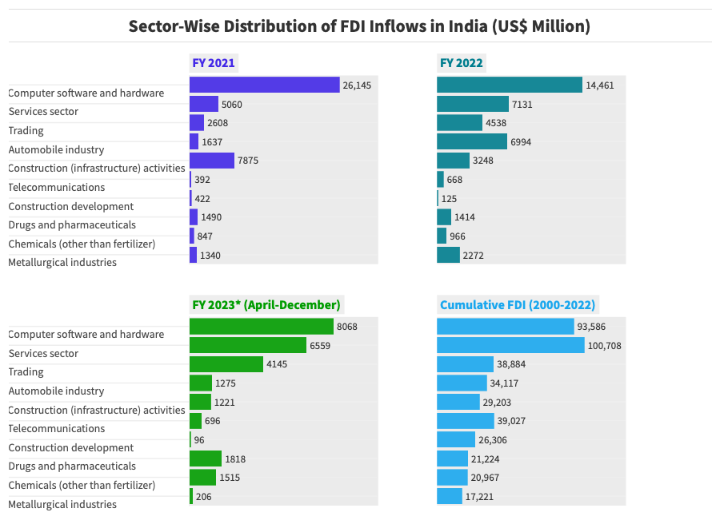

**Interpretation: -**

In the FY 2023, foreign investors showed keen interest in multiple sectors in India, with the highest FDI inflows seen in computer software and hardware, attracting investments worth US$9.39 billion. The services sector also received significant foreign investment, totalling US$8.70 billion, covering financial, banking, insurance, and business services.

Additionally, the trading sector received investments worth US$4.79 billion, followed by drugs and pharmaceuticals (US$2.05 billion), the automobile industry (US$1.90 billion), chemicals (US$1.85 billion), and construction (infrastructure) activities (US$1.70 billion).

* 1. **States Attracting Highest FDI Equity Inflow**

|  |  |  |  |  |  |
| --- | --- | --- | --- | --- | --- |
|  | **State/UT** | **2019-20 (From OCT 2019)** | **2020-21** | **2021-22** | **2022-23 (Till December 2022)** |
| 1 | Andhra Pradesh | 200.9664 | 85.8487 | 224.9645 | 248.1335 |
| 2 | Arunachal Pradesh | 0.6052 | 4.9496 | NA | NA |
| 3 | Assam | 2.9344 | 11.1881 | 4.4031 | 1.9012 |
| 4 | Bihar | 5.5396 | 45.0842 | 116.4702 | 47.3379 |
| 5 | Chandigarh | 3.5809 | 10.0332 | 51.3744 | 10.7926 |
| 6 | Daman and Diu | 0.0273 | 0.0001 | 0.9834 | 1.18 |
| 7 | Dadra and Nagar Haveli | 2.9377 | 5.0293 | 142.0736 | 17.5647 |
| 8 | Delhi | 3998.4895 | 5471.0525 | 8189.352 | 6113.8735 |
| 9 | Goa | 64.9332 | 16.3327 | 37.1201 | 11.7214 |
| 10 | Gujarat | 2591.3955 | 21890.1728 | 2705.5173 | 4141.0093 |
| 11 | Haryana | 726.9264 | 1697.0143 | 2798.4821 | 2010.2872 |
| 12 | Himachal Pradesh | 11.9116 | 10.921 | 137.9891 | 19.6237 |
| 13 | Jammu and Kashmir | NA | 0.2093 | 0.1456 | 0.7177 |
| 14 | Jharkhand | 1852.0386 | 792.0575 | 6.4337 | 5.4885 |
| 15 | Karnataka | 4288.9831 | 7670.4915 | 22071.9375 | 8772.6367 |
| 16 | Kerala | 57.4068 | 212.2728 | 347.7665 | 142.5403 |
| 17 | Ladakh | NA | 0.0274 | 0.1352 | 0.0616 |
| 18 | Madhya Pradesh | 75.6937 | 206.6322 | 208.5263 | 30.5119 |
| 19 | Maharashtra | 7556.2517 | 16169.7897 | 15438.6319 | 10765.6515 |
| 20 | Meghalaya | NA | NA | 1.0965 | NA |
| 21 | Nagaland | NA | NA | 0.0139 | NA |
| 22 | Odisha | 13.0463 | 19.7563 | 95.328 | 28.4086 |
| 23 | Puducherry | 0.4466 | 58.2133 | 0.1948 | 4.4403 |
| 24 | Punjab | 96.7744 | 644.4576 | 127.0072 | 26.9365 |
| 25 | Rajasthan | 189.1766 | 272.2243 | 707.0874 | 764.3981 |
| 26 | Tamil Nadu | 1006.0699 | 2323.4591 | 3003.1578 | 1890.2797 |
| 27 | Telangana | 679.8587 | 1155.4906 | 1606.8937 | 1080.6871 |
| 28 | Tripura | NA | 0.431 | 0.1312 | NA |
| 29 | Uttar Pradesh | 242.8746 | 421.7904 | 216.9689 | 368.735 |
| 30 | Uttarakhand | 14.695 | 5.3028 | 103.9931 | 2.8226 |
| 31 | West Bengal | 190.7624 | 415.3737 | 427.7678 | 238.4974 |
| 32 | Andaman and Nicobar | 7.0117 | 19.933 | 1.3214 | NA |

**Top 10 States Receiving Highest FDI in India (October 2019 - March 2023) (US$ Billion)**

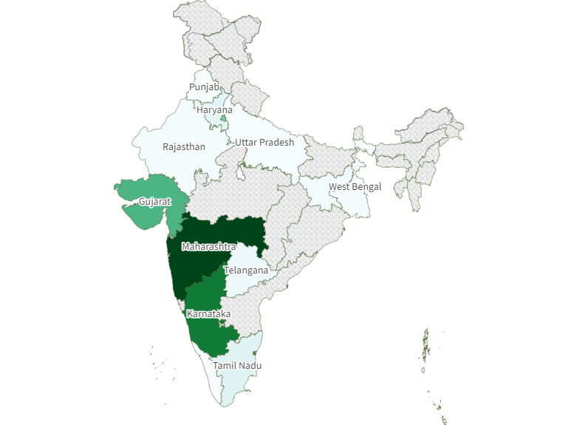

**53.97**

**0.78**



**CHAPTER NO. 5**

**FINDING AND SUGGESTION**

**5.1) FINDING**

* After 2005 the Cumulative-wise FDI inflow has continuously increased.
* The Singapore country has top investing country in India (Table 4.2).
* The highest investment has been made in computer software and hardware sector in the financial year 2023.
* In India in 2023, the state of Maharashtra has the highest FDI investment.
* Mauritius, Singapore and USA have seen more investment than other countries in the last three years.

**5.2) SUGGESTION**

* + - 1. FDI in computer software and hardware has been encouraged with a focus on technology transfer to promote domestic innovation and expertise, and should continue to grow.
      2. The eastern states in India receive very little FDI, so industry in eastern states should be promoted and infrastructure development should be increased.
      3. Since 2001 till now, FDI in India has been continuously increasing and it is necessary to make effort to continue it from now on.
      4. Prioritize stringent security assessments and technology transfer agreements to safeguard national interests when allowing FDI in defence industries.

* **CONCLUSION**

Trends are just relative numbers which might differ from that of the original numbers. It only shows the relation in the form of percentage growth over last year whereas the foreign direct investment keeps on coming into the economy. There can be many factors responsible for such variations in the trends of foreign direct investment inflows like economic, institutional and political factors. These factors include economic growth of the country, market size, resource location, return on investment, inflation, government regulation, political stability, tax policies and foreign exchange rate among others.

* **BIBLIOGRAPHY**

1. Gov. of India, Ministry of Finance, Department of Economic Affairs “Economic Survey 2022-23” (page no. 271, 280)
2. Nandita Dasgupta, Department of Economics, University of Maryland, Baltimore country (UMBC), Research Paper (Page no. 18,19)
3. Rajib Bhattacharya, Journal of Humanities and Social Science, ‘The Opportunities and Challenges of FDI in Retail Sector in India” (Page no. 99)

**Websites**

* [www.india-briefing.com](http://www.india-briefing.com)
* <https://pib.gov.in>
* [www.dpiit.gov.in](http://www.dpiit.gov.in)
* [www.investindia.gov.in](http://www.investindia.gov.in)
* <https://rbi.org.in>
* <https://eoi.gov.in>

GUIDE STUDENT MEETING RECORD

|  |  |
| --- | --- |
| Student Name |  |
| Contact No. |  |
| Email-id |  |
| Institute Guide Name |  |
| Contact No. |  |
| Email-id |  |
| Organization Guide Name |  |
| Designation |  |
| Contact No. |  |
| Email-id |  |
| Website of Organization |  |
| Specialization of Project |  |
| Topic of Project |  |

.

|  |  |  |  |  |  |
| --- | --- | --- | --- | --- | --- |
| Sr.  No. | Date | Description | Discussion | Signature of Guide | Signature of student |
| 1 |  | Review of Literature -Submission |  |  |  |
| 2 |  | Objective, Research Methodology Finalization |  |  |  |
| 3 |  | Finalization of Chapter No.1 –Introduction to the study |  |  |  |
| 4 |  | Finalization of Chapter No.2-Theoretical Background |  |  |  |
| 5 |  | Finalization of Chapter No.3-Introdcution to the organization/Industry |  |  |  |
| 6 |  | Questionnaire Finalization |  |  |  |
| 7 |  | Finalization of Chapter No.4-Data Analysis, Findings, Suggestions |  |  |  |
| 8 |  | Submission of First Draft of project report |  |  |  |
| 9 |  | Submission of Final Draft of project report |  |  |  |
| 10 |  | PPT Presentation of Project work |  |  |  |

Signature

Head of Department /Director/Principal